11. PNEUMATIC CYLINDER OPERATION

AIM:To develop ladder logic for single acting and double acting pneumatic cylinder operation using PLC.
APPARATUS REQUIRED:

1. SIEMENS PLC Trainer kit.
2. PC.
3. Ethernet cable.

PROCEDURE:
- Load the Software to the PC.
- Open the Software.
- Switch ON the PLC Trainer .
- Open the New folder and draw the ladder logic program.
- Connect the PLC to PC.
- Select the correct hardware Configuration [Sl. No].
- Store the Program to PLC.
- Run the Program.
- Verify the performance of single acting pneumatic cylinder operation.

- Single acting pneumatic cylinder operation
PROBLEM DESCRIPTION: The operation of single Acting pneumatic cylinder by using two push buttons PB1 and PB2.PB1 is for start the operation and is for stop the operation.
DIAGRAM:
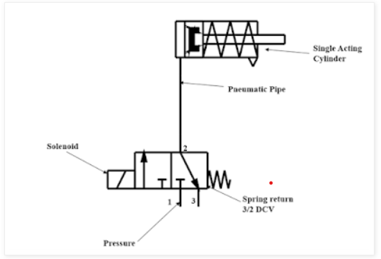

LADDER DIAGRAM:

- Double acting pneumatic cylinder operation

PROBLEM DESCRIPTION: The operation of double Acting pneumatic cylinder by using two push buttons PB1 and PB2.PB1 is for start the operation and is for stop the operation.

DIAGRAM:

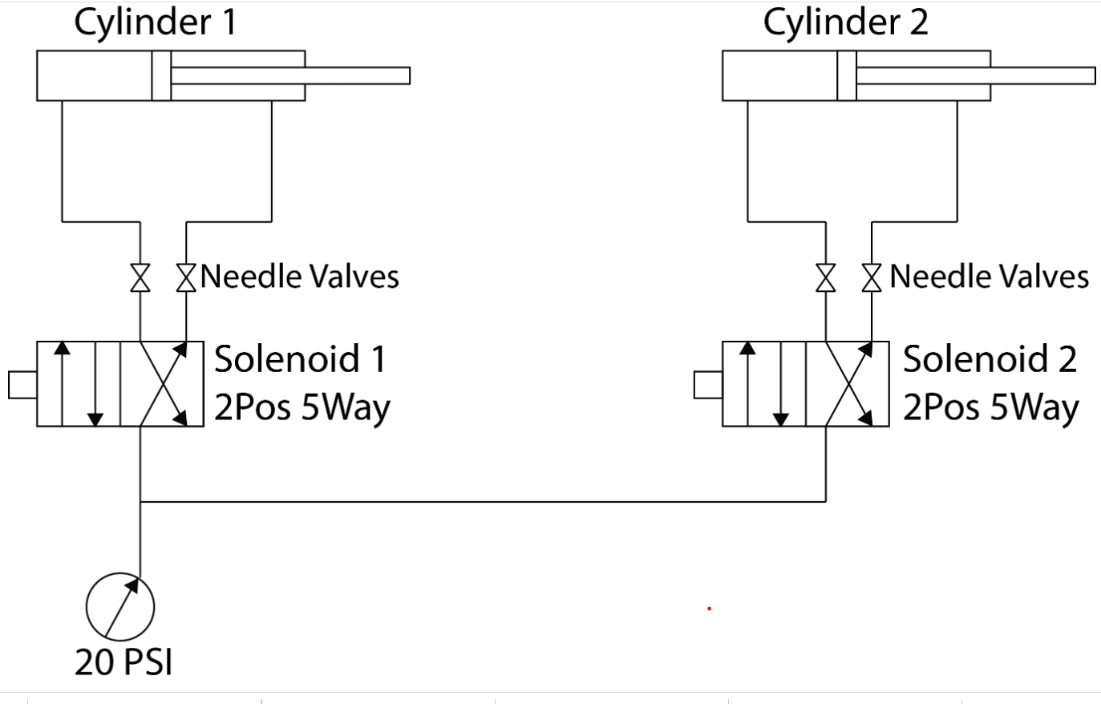

LADDERDIAGRAM:

RESULT:
Thus the double acting pneumatic cylinder operation is carried out and verified using SIEMENS PLC.

ASSIGNMENT
1. CONTROL OF DOUBLE ACTING CYLINDER OPERATION
AIM:To develop ladder logic for control of double acting pneumatic cylinder operation using PLC.
APPARATUS REQUIRED:

1. SIEMENS PLC Trainer kit.
2. PC.
3. Ethernet cable.

PROCEDURE:
- Load the Software to the PC.
- Open the Software.
- Switch ON the PLC Trainer .
- Open the New folder and draw the ladder logic program.
- Connect the PLC to PC.
- Select the correct hardware Configuration [Sl. No].
- Store the Program to PLC.
- Run the Program.
- Verify the performance of single acting pneumatic cylinder operation.
PROBLEM DESCRIPTION: The operation of double Acting pneumatic cylinder by using two push buttons PB1 and PB2.PB1 is for start the operation and is PB2 for stop the operation.when the cylinder 1 is extended and the cylinder 2 should be retracted and vice versa.
DIAGRAM:



LADDER DIAGRAM:

RESULT:
Thus the control of double acting pneumatic cylinder operation is carried out and verified using SIEMENS PLC.

